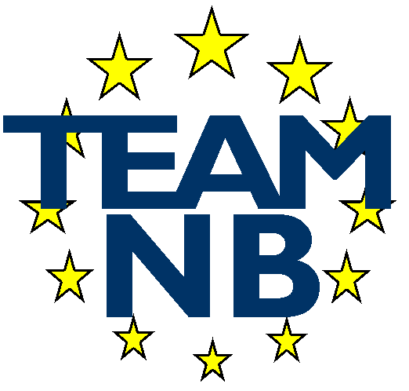 | The European Association Medical devices - Notified Bodies  MEMBER APPLICATION

I confirm we wish to be a member of the association TEAM-NB (European Association of Notified Bodies for Medical Devices).
I send as part of my candidature the signed latest version of the Code of Conduct and I agree to be invoiced the yearly fees. I will be then given access to the private part of the web site and considered as a candidate member.
Before the general assembly will confirm my organization as a member, we will be audited following the Code of Conduct requirements by the independent supervisory audit team of TEAM-NB.

Name of Notified Body
Notified Body Number
Address
Post Code
Locality
Country
Phone | …… - …… - ……………………..  Country Code – Area Code -
Fax | …… - …… - ……………………..  Country Code – Area Code -
Web site
VAT Number
Notified for Directives  (tick where appropriate) | ❑ 90/385/EEC Directive   93/42/EEC Directive   98/79/EC Directive
Name of contact
Title of Contact
E-mail of Contact
Direct Phone | …… - …… - ……………………..  Country Code – Area Code -

Signature :
Name of signatory : | ……………………………………………
Date : | ……………………………………………

Please could you complete this form and send it back to the email address to the attention of Françoise SCHLEMMER (info@team-nb.org).

